MAZE GAME DESCRIPTION

I have used as many elements of the Unity game engine as possible to create an interactive game environment with a FPS player. I focused on creating a visually aesthetic environment that draws the player in. It combines elements of probuilder, animation, rendering cameras , and direct as well as other sources of lighting.

BEGINNING OF GAME DESIGN

TERRAIN (25%)

I have included environment textures, trees and foreign materials, water, fog, wind, and billboard textures and materials to the outdoor section of my game.

I have also added a first-person controller with which the player can navigate the scene.

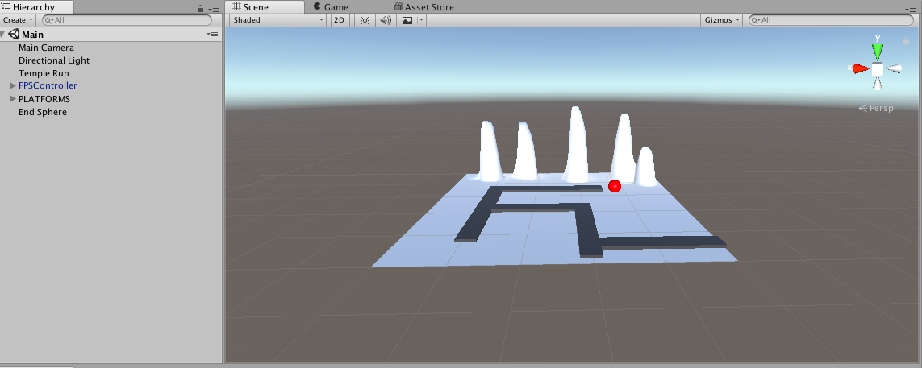

I had a very basic terrain with a few platforms and a sphere made using Unity primitives. I had also added some texture and height to terrain as shown above. I made my very first material too with the shade red.

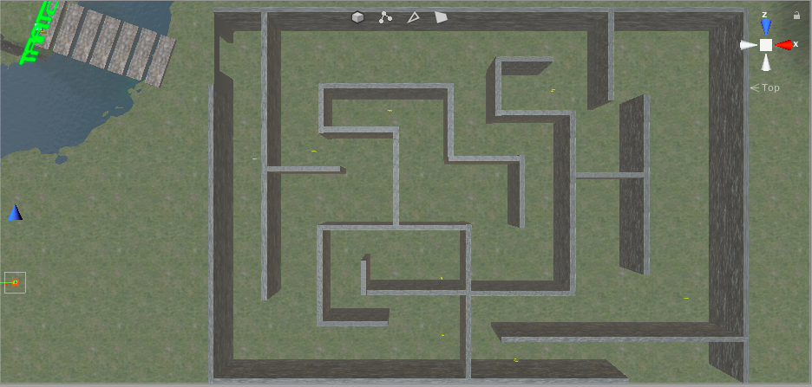

I started adding some texture and details to my terrain like grass, trees and hills and crevices as well as creating a material for my maze walls. I then started creating the basic layout of my maze structure using unity shapes and also created a coin prefab with an animation. The goal was to get this coin to be picked up by the player as a trigger. I also added normal maps to the game

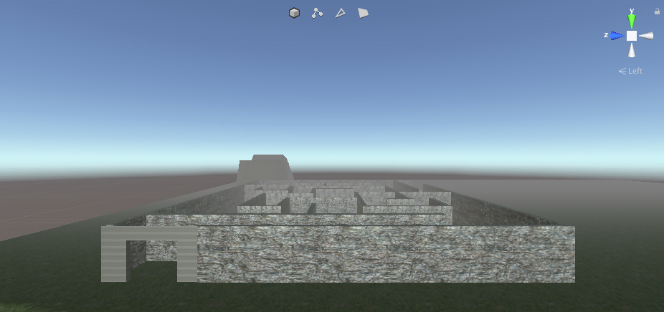

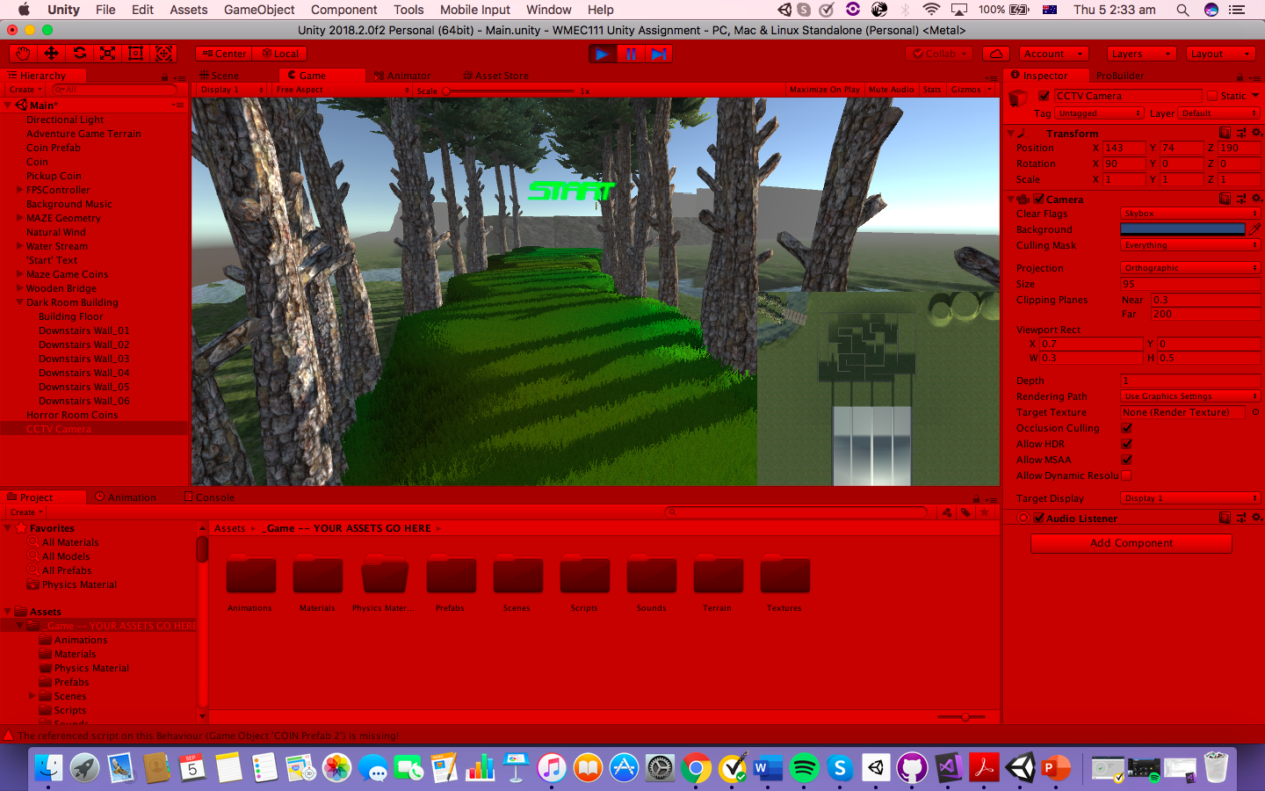

I then added a FPS controller to my scene and edited the directional lighting in my terrain. I also added a stream and a bridge using the script provided by unity. This was followed by adding a minimap camera and some post-processing effects to the game enhance the game-play feel.

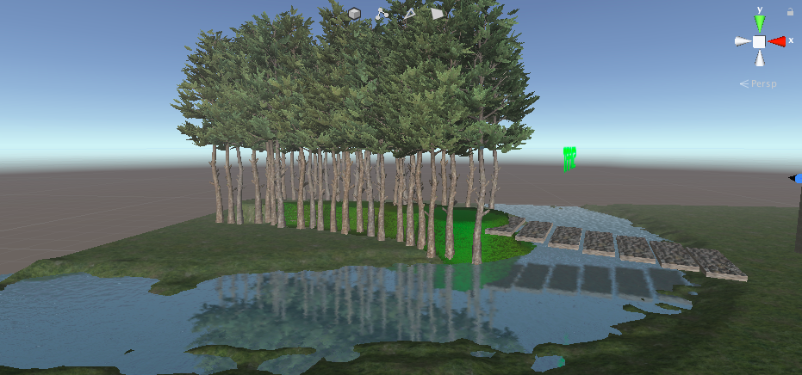

I also attempted to create hinge joint bridge.

INDOOR SECTION (25%)

For the indoor section of the game I have used created materials, textures, lighting, pro-builder shapes to create a simple maze like game that requires players to collect coins before they reach the end of the game. I have also used textures for bump mapping and normal maps.

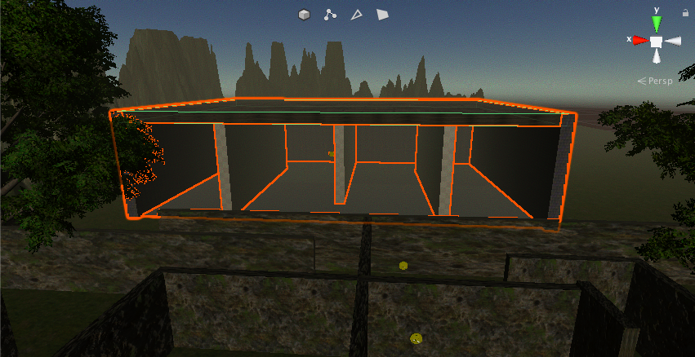

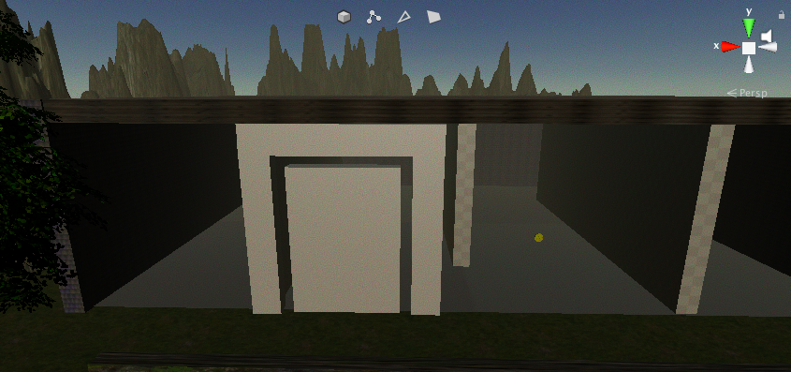

I also added some point lights to the inside of my building to keep it lit up during the night cycle of the game.

Door animation using trigger animation is also part of my game.

MODIFICATIONS OT GAME DESIGN DOCUMENT

I made a few major changes to the original game idea because I realised it is difficult to create a running game within Unity and that a maze game allowed the player to explore their surroundings and find it more adventurous and engaging.